Strengths of Materials

Chapter 1 Homework Problems

Problem 1.1

A hollow cylindrical tube is going to be subjected to a 10,000 lb tension force. If the outer diameter of the tube is to be one inch and the stress is not to exceed 30 ksi, what is the minimum thickness required for the tube?

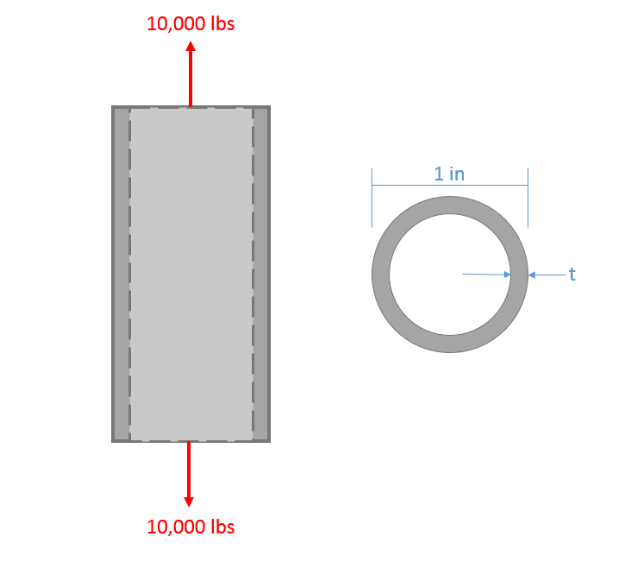

(Solution: t min = .121 in)

Problem 1.2

A set of speakers as shown below are suspended from the ceiling using cables. If the tensile stress in the cable is not to exceed 250 MPa and the diameter of the cables are 1 cm, what is the maximum speaker mass (assume they are equal) that the cables can support?

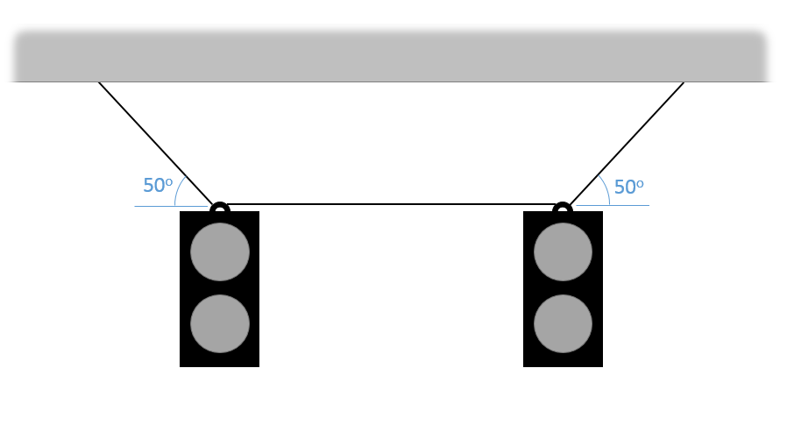

(Solution: Max mass = 1533 kg)

Problem 1.3

A shear is being used to cut steel rebar into smaller sections. If the rebar has a diameter of 1.2 cm and the shear is pressing down with a force of 4 kN, what is the shearing stress created in the rebar?

(Solution: $τ=35.4 MPa$)

Problem 1.4

A twenty-ton hydraulic press is being used to punch square holes in half inch aluminum plate. If the shear strength of the plate is 30 ksi, what is the maximum side length (s) for the square holes the punch can create?

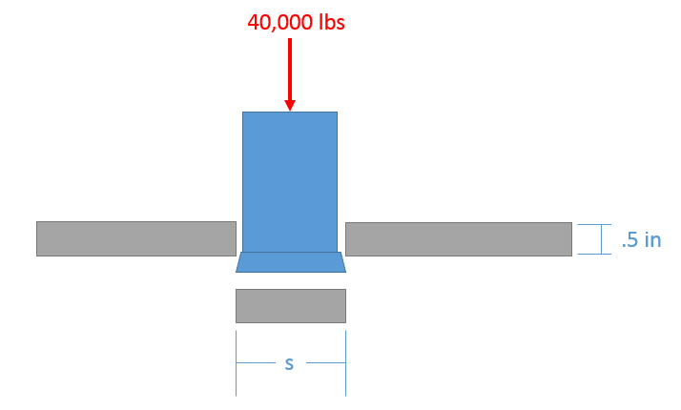

(Solution: side = .667 inch max)

Problem 1.5

A chain is to be subjected to a 2kN force as shown below. If we assume the chain will fail via a normal stress at cross section A, we know the steel is expected to fail at a stress of 250 MPa, and we wish to create a design with a Safety Factor of 3, what should the diameter of the chain link material be? Assume the links have circular cross sections at A.

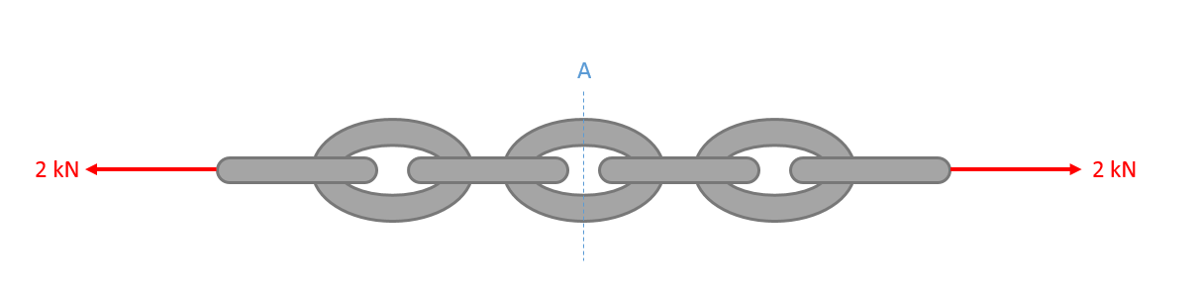

(Solution: D = 3.91 mm minimum)

Problem 1.6 Replace Image

Two steel bolts as shown below support the orange cross beam. The bolts have a diameter of .375 inches and have a shearing strength of 40 ksi. If we wish to have a safety factor of 2, what is the maximum rated load on the orange cross beam?

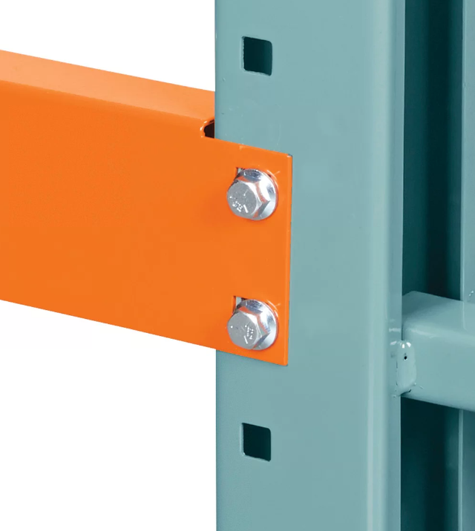

(Solution: Fmax=4,418 lbs)